sarathkc@krisemidesigntech.com

Mi-V RV32 Firmware Integration

1. Project Objective
The objective was to replace the original SmartFusion2 MSS-based processor architecture with the Microchip Mi-V RV32 RISC-V soft processor and verify firmware execution through simulation.
  - Block Diagram

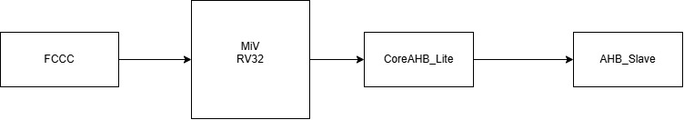
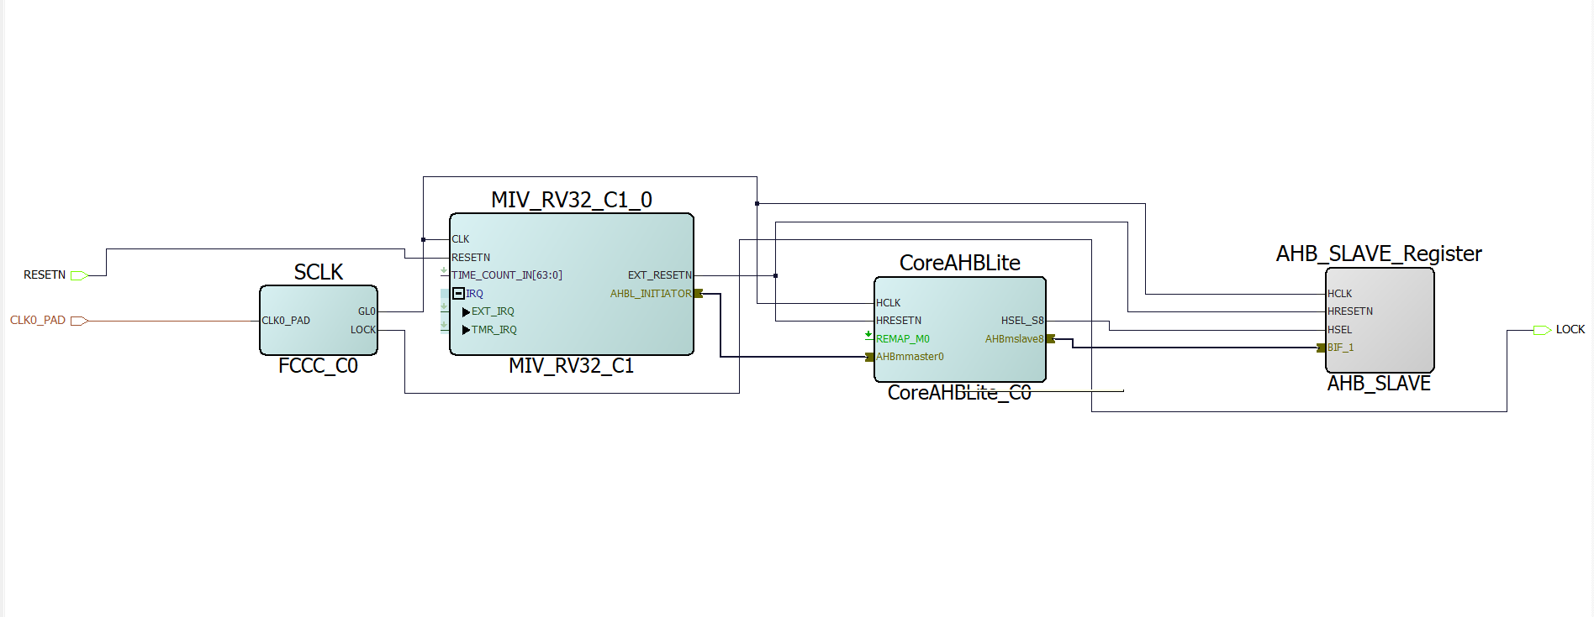
1.2 Smart Design View:

2. Mi-V RV32 Configuration
The original MSS was removed from the SmartDesign.
The current SmartDesign contains:
- MIV_RV32_C1
- CoreAHBLite_C0
- FCCC_C0
- AHB_SLAVE
The Mi-V configuration used:
Parameter | Configuration
Processor | Mi-V RV32
Version | 3.1.200
ISA | RV32IMC
M extension | Enabled
C extension | Enabled
F extension | Disabled
Multiplier | Fabric
AHB Initiator | AHBLite
APB Initiator | Disabled
AXI Initiator | Disabled
ICache | Disabled
TCM | Enabled
BootROM | Disabled
TCM Access Support | Disabled
Debug | Disabled
Trace | Disabled
Hart ID | 0

3. Memory Architecture
Two separate address regions are used.
3.1 Mi-V TCM
The processor TCM is mapped to: 0x4000_0000 – 0x4000_3FFF
This provides:16 KB TCM
The reset vector was therefore configured as: 0x4000_0000
This allows the processor to begin execution directly from TCM.

3.2 AHB Peripheral Space
The Mi-V AHB initiator is configured for: 0x8000_0000 – 0x8FFF_FFFF
The CoreAHBLite interconnect uses slot 8 for the custom AHB slave.
Therefore: AHB Slave Base Address = 0x8000_0000
The firmware accesses the peripheral using:
#define AHB_SLAVE_REG (*(volatile uint32_t *)0x80000000u)
4. Firmware Development
A dedicated SoftConsole RISC-V project named:
test_riscv
was created.
The firmware uses a custom linker script because the program must execute from Mi-V TCM.
The linker memory definition is:
MEMORY
{
TCM (rwx) : ORIGIN = 0x40000000, LENGTH = 16K
}
The reset entry point is:
ENTRY(_start)
- The startup code initializes the stack and calls main().
The intended application is:
#include <stdint.h>
#define AHB_SLAVE_REG (*(volatile uint32_t *)0x80000000u)
int main(void)
{
AHB_SLAVE_REG = 0x12345678u;
while (1)
{
}
}

5. HEX Address Offset Handling
The firmware HEX file originally contains the TCM's physical/linker address.
The SoftConsole build was configured with: “--change-section-lma *-0x40000000”
This removes the 0x40000000 address offset from the generated HEX data so that it can be loaded into the simulation RAM starting at memory index 0.

6. Mi-V TCM Simulation Loading
The generated TCM hierarchy was identified in QuestaSim:
DUT
└── MIV_RV32_C1_0
└── MIV_RV32_C1_0
└── u_ipcore_0
└── gen_tcm0
└── u_subsys_TCM_0
└── tcm_ram
└── u_ram_0
└── gen_tcm
└── mem
The actual RAM array is: gen_tcm.mem
The simulation testbench uses:
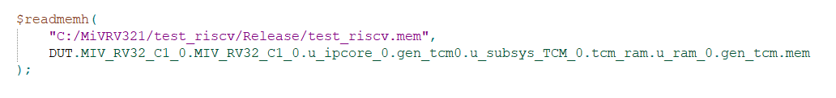
This successfully loaded the firmware.

7. Simulation
Test bench :
`timescale 1ns / 1ps

module testbench;

reg CLK0_PAD;
reg RESETN;
wire LOCK;

initial begin
CLK0_PAD = 1'b0;

forever begin
#5;
CLK0_PAD = ~CLK0_PAD;
end
end

initial begin
RESETN = 1'b0;

$display("==============================================");
$display(" RESET ASSERTED");
$display("==============================================");
$display("[%0t ns] RESETN = 0", $time);

// Wait for CCC-generated Mi-V clock to become active
wait (LOCK == 1'b1);

// Give the generated clock some cycles before releasing reset
#100;

RESETN = 1'b1;

$display("==============================================");
$display(" RESET RELEASED AFTER FCCC LOCK");
$display("==============================================");
$display("[%0t ns] RESETN = 1", $time);
end

frimware DUT (
.CLK0_PAD (CLK0_PAD),
.RESETN (RESETN),
.LOCK (LOCK)
);

initial begin

$display("==============================================");
$display(" Loading Mi-V RV32 firmware into TCM");
$display("==============================================");

$readmemh(
"C:/MiVRV321/test_riscv/Release/test_riscv.mem",
DUT.MIV_RV32_C1_0.MIV_RV32_C1_0.u_ipcore_0.gen_tcm0.u_subsys_TCM_0.tcm_ram.u_ram_0.gen_tcm.mem
);

$display("Firmware loaded into Mi-V TCM");
$display("");

// Print first 8 TCM locations
$display("TCM[0] = %08h",
DUT.MIV_RV32_C1_0.MIV_RV32_C1_0.u_ipcore_0.gen_tcm0.u_subsys_TCM_0.tcm_ram.u_ram_0.gen_tcm.mem[0]);

$display("TCM[1] = %08h",
DUT.MIV_RV32_C1_0.MIV_RV32_C1_0.u_ipcore_0.gen_tcm0.u_subsys_TCM_0.tcm_ram.u_ram_0.gen_tcm.mem[1]);

$display("TCM[2] = %08h",
DUT.MIV_RV32_C1_0.MIV_RV32_C1_0.u_ipcore_0.gen_tcm0.u_subsys_TCM_0.tcm_ram.u_ram_0.gen_tcm.mem[2]);

$display("TCM[3] = %08h",
DUT.MIV_RV32_C1_0.MIV_RV32_C1_0.u_ipcore_0.gen_tcm0.u_subsys_TCM_0.tcm_ram.u_ram_0.gen_tcm.mem[3]);

$display("TCM[4] = %08h",
DUT.MIV_RV32_C1_0.MIV_RV32_C1_0.u_ipcore_0.gen_tcm0.u_subsys_TCM_0.tcm_ram.u_ram_0.gen_tcm.mem[4]);

$display("TCM[5] = %08h",
DUT.MIV_RV32_C1_0.MIV_RV32_C1_0.u_ipcore_0.gen_tcm0.u_subsys_TCM_0.tcm_ram.u_ram_0.gen_tcm.mem[5]);

$display("TCM[6] = %08h",
DUT.MIV_RV32_C1_0.MIV_RV32_C1_0.u_ipcore_0.gen_tcm0.u_subsys_TCM_0.tcm_ram.u_ram_0.gen_tcm.mem[6]);

$display("TCM[7] = %08h",
DUT.MIV_RV32_C1_0.MIV_RV32_C1_0.u_ipcore_0.gen_tcm0.u_subsys_TCM_0.tcm_ram.u_ram_0.gen_tcm.mem[7]);

end

initial begin

// Wait until just before reset release
#900;

$display("");
$display("==============================================");
$display(" RESET DEBUG - BEFORE RELEASE");
$display("==============================================");

$display("[%0t ns] RESETN = %b",
$time, RESETN);

$display("[%0t ns] toggle_hart_soft_reset = %b",
$time,
DUT.MIV_RV32_C1_0.MIV_RV32_C1_0.u_ipcore_0.u_subsys_interconnect_0.u_subsys_regs.toggle_hart_soft_reset);

$display("[%0t ns] hart_soft_reset_reg = %b",
$time,
DUT.MIV_RV32_C1_0.MIV_RV32_C1_0.u_ipcore_0.u_subsys_interconnect_0.u_subsys_regs.subsys_hart_soft_reset_reg);

// Wait 200 ns after reset release
#200;

$display("");
$display("==============================================");
$display(" RESET DEBUG - AFTER RELEASE");
$display("==============================================");

$display("[%0t ns] RESETN = %b",
$time, RESETN);

$display("[%0t ns] toggle_hart_soft_reset = %b",
$time,
DUT.MIV_RV32_C1_0.MIV_RV32_C1_0.u_ipcore_0.u_subsys_interconnect_0.u_subsys_regs.toggle_hart_soft_reset);

$display("[%0t ns] hart_soft_reset_reg = %b",
$time,
DUT.MIV_RV32_C1_0.MIV_RV32_C1_0.u_ipcore_0.u_subsys_interconnect_0.u_subsys_regs.subsys_hart_soft_reset_reg);

end

initial begin

$display("");
$display("==============================================");
$display(" Mi-V RV32 Firmware Simulation");
$display("==============================================");

wait (LOCK == 1'b1);

$display("");
$display("[%0t ns] FCCC LOCK = 1", $time);

#50000;

$display("");
$display("==============================================");
$display(" SIMULATION FINISHED");
$display("==============================================");

$display("[%0t ns] Simulation finished", $time);

$finish;

end

endmodule

Compilation result :
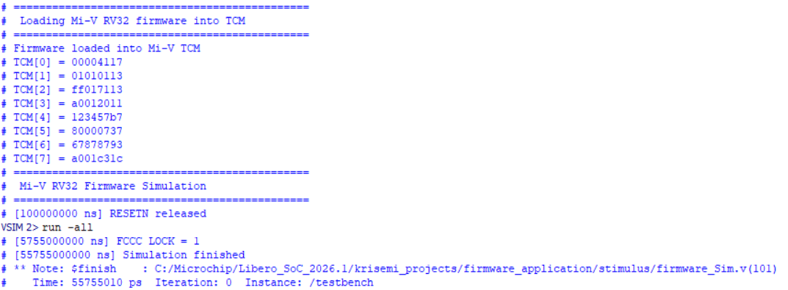

This was an important milestone.
It proves that:
- The .mem file is valid.
- $readmemh successfully loaded it.
- The hierarchical path reaches the actual Mi-V TCM RAM.
- The expected firmware words are present in the RAM before execution.

Mi-V RV32 Instruction Fetch Verification:
After correcting the reset release sequencing, the Mi-V RV32 successfully initiated multiple instruction fetch transactions from the integrated TCM. The instruction request address advanced sequentially from 0x0000 through 0x0014, with valid instruction responses observed from the TCM.

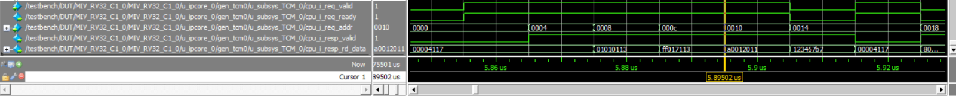

CoreABH_Lite transaction
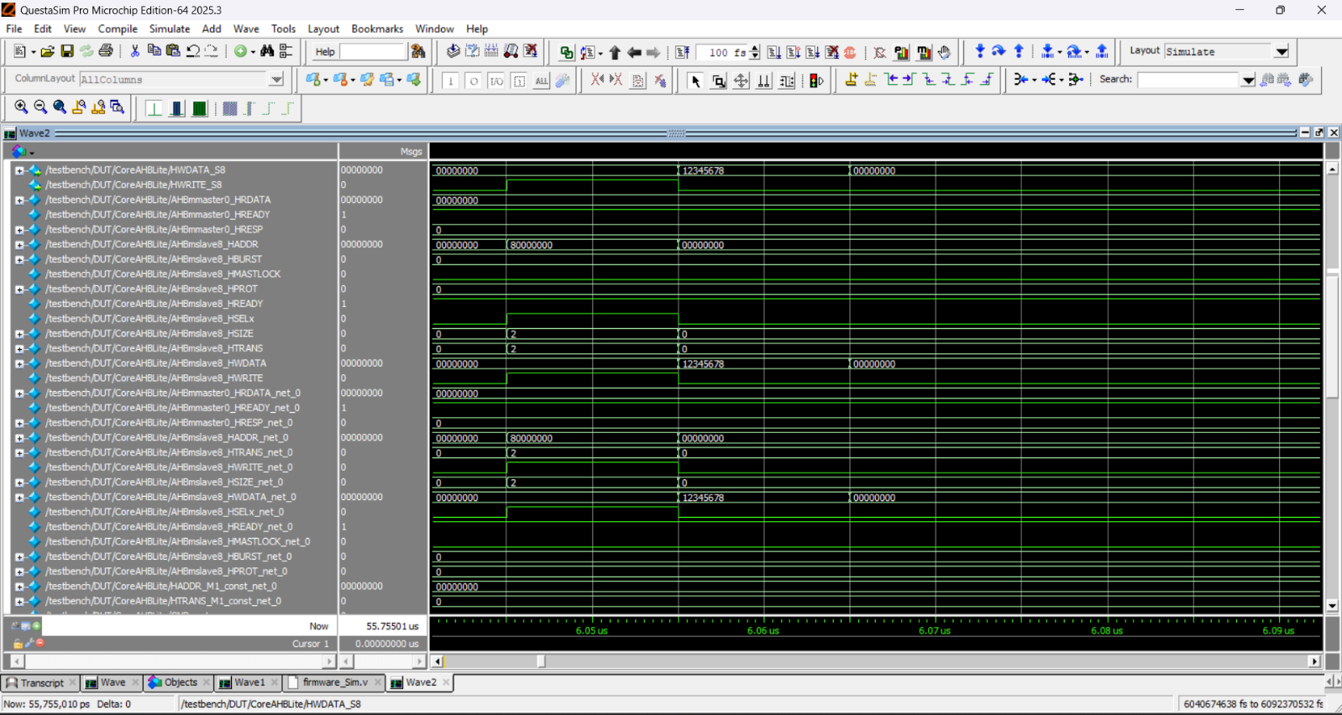

CoreAHBLite signal | Observed
AHBmslave8_HADDR | 0x80000000
AHBmslave8_HWDATA | 0x12345678
AHBmslave8_HWRITE | 1
AHBmslave8_HTRANS | 2 (NONSEQ)
AHBmslave8_HSIZE | 2
AHBmslave8_HSELX | 1
AHBmslave8_HREADY | 1
AHBmslave8_HRESP | 0

AHB_Slave transaction :
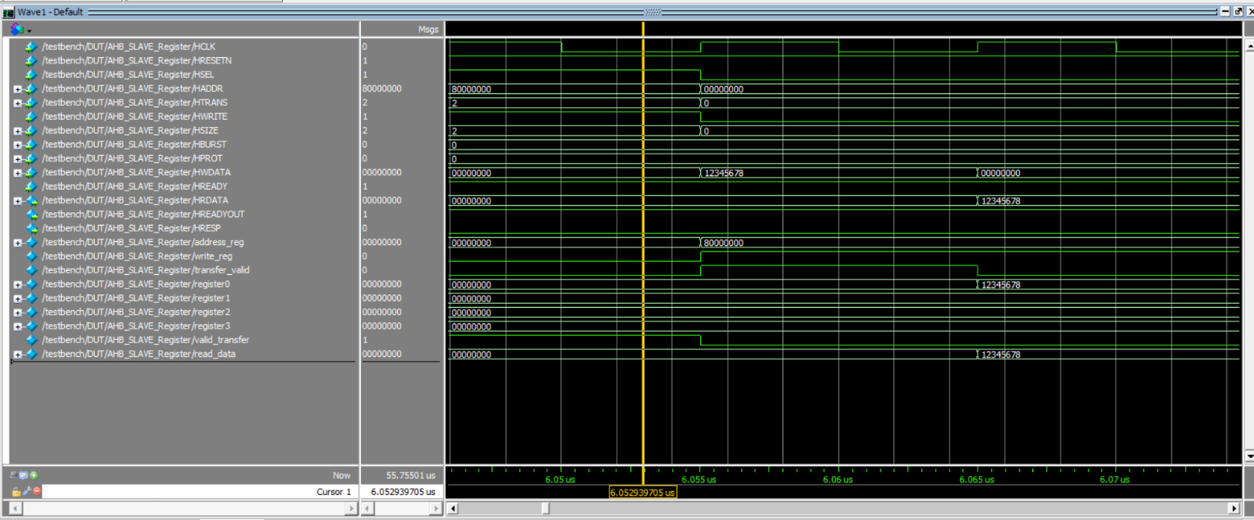

Signal | Observed
HSEL | 1
HADDR | 0x80000000
HTRANS | 2 → NONSEQ
HWRITE | 1
HSIZE | 2
HBURST | 0
HWDATA | 0x12345678
HREADY | 1
HRESP | 0

address_reg = 0x80000000
transfer_valid = 1
and subsequently: register0 = 0x12345678
So the data has actually been accepted and stored by the slave.

Check Sheet:
Current Verification Status
The current status can be summarized as:
Verification Item | Status
Mi-V integrated into SmartDesign | PASS
MSS removed from active architecture | PASS
CoreAHBLite connection | PASS
AHB Slave connection | PASS
Mi-V TCM enabled | PASS
Reset vector configured | PASS
SoftConsole RISC-V project | PASS
Linker configured for TCM | PASS
Firmware compilation | PASS
HEX generation | PASS
HEX → MEM conversion | PASS
$readmemh TCM loading | PASS
TCM contents verified | PASS
FCCC clock lock | PASS
First instruction fetch | PASS
Second instruction fetch | PASS
Firmware reaches main() | CONFIRMED
AHB write 0x12345678 | CONFIRMED

Current Project Conclusion
The Mi-V RISC-V based MSS/FPGA system has been successfully integrated and functionally verified at the simulation level. The Mi-V processor is able to fetch instructions from the configured TCM, confirming that the firmware image is correctly loaded and accessed by the processor. The observed instruction data from the IFU matches the corresponding TCM contents.
The AHB communication path has also been verified. A valid AHB write transaction with address 0x80000000 and data 0x12345678 was observed passing through the CoreAHBLite interconnect to the custom AHB_SLAVE. The slave successfully captured and stored the data in its register, and the same value was subsequently observed during readback.

Debugging Learnings

During the development and simulation of the MSS_FPGA design, several important debugging lessons were identified. These helped in understanding the interaction between the Mi-V RISC-V processor, TCM, clock/reset infrastructure, CoreAHBLite, and the custom AHB slave.
1. Reset and Clock Sequencing
A major issue was identified where the external clock was running, but the internal Mi-V clock generated through the FCCC/CCC was not active until the clock lock was established. Releasing RESETN before the internal clock became active resulted in internal registers remaining in an unknown (X) state. The reset sequence was therefore changed to wait for LOCK = 1 before releasing reset.
Learning: Reset release must be synchronized with the availability of the internally generated processor clock.
2. Understanding Simulation Hierarchy
Several debugging issues were caused by confusion between the design hierarchy, simulation hierarchy, and generated IP hierarchy. Checking the exact hierarchy before probing internal signals was found to be important.
Learning: Always verify the actual simulation hierarchy before adding or examining internal signals.
3. TCM and Instruction Fetch Debugging
The firmware was loaded directly into the inferred TCM using $readmemh. Instead of assuming that the processor was executing the firmware, the instruction-fetch interface was traced through the IFU and TCM.
For example:
TCM[7] = A001C31C
IFU response data = A001C31C
This provided direct evidence that the Mi-V processor was receiving instructions from the loaded TCM contents.
Learning: In processor debugging, verify the complete path:
Firmware → TCM → IFU request → TCM response → CPU
rather than relying only on the CPU PC.
4. examine vs Waveform Debugging
It was observed that Questa's examine command reports the signal value at the current simulation time, not its historical value. Therefore, using examine alone can be misleading when trying to understand what happened earlier in the simulation.
Learning: Use the waveform for time-dependent debugging and use examine mainly for checking the current signal state.
5. AHB Transaction-Level Debugging
The AHB path was debugged by following a transaction through the system rather than checking individual modules independently.
The transaction:
HADDR = 0x80000000
HWRITE = 1
HWDATA = 0x12345678
was observed at the CoreAHBLite and AHB slave interfaces.
Learning: For bus-based systems, trace the same transaction from master → interconnect → slave → return path.
6. CoreAHBLite Address Decoding
The CoreAHBLite waveform showed HSELX = 1 for the selected slave while the address and write data were correctly propagated.
This confirmed that the address decoding and slave selection were functioning as expected.
Learning: For interconnect debugging, HSEL, HADDR, HTRANS, HWRITE, and HWDATA are key signals for establishing whether a transaction reaches the intended peripheral.
7. AHB Slave Register Verification
The custom AHB slave was verified beyond simply observing bus activity. The written value:
0x12345678
was stored in register0 and subsequently returned during readback.
Learning: A peripheral should be considered functionally verified only after confirming both write → storage and read → readback behavior.
8. Avoiding Premature Root-Cause Conclusions
The simulation produced several port-width warnings, including 14-bit/32-bit address mismatches. These warnings were recorded, but they were not immediately treated as the cause of the observed behavior because the relevant TCM and AHB transactions were functioning correctly.
Learning: A simulation warning should be investigated, but its causal relationship to a failure should be established through evidence rather than assumption.

